**Project Based Learning Report**

on

**Bit rate error (BER) simulation of Sparse Code Multiple Access (SCMA) scheme (python)**

Submitted in the partial fulfillment of the requirements.

For the Project based learning in **5G Architecture**

in

Electronics & Communication Engineering

By

ANSHUMAN PRN-2114110433

ARUN DESHMUKH PRN-2114110442

UTKARSH MAURYA PRN-2114110490

Under the guidance of Course In-charge

**Prof. S.V. Dhole**

Department of Electronics & Communication Engineering

Bharati Vidyapeeth

(Deemed to be University)

College of Engineering,

Pune – 4110043

Academic Year: 2023-24

**CERTIFICATE**

This is to be Certified that the Project Based Learning report entitled, **“Bit rate error (BER) simulation os Sparse Code Multiple Access (SCMA) scheme (python)”** Work is done by

ANSHUMAN PRN-2114110433

ARUN DESHMUKH PRN-2114110442

UTKARSH MAURYA PRN-2114110490

In partial fulfillment of the requirements for the award of credits for Project Based Learning (PBL) in **5G Architecture** Bachelor of Technology Semester VIII, Electronics and Communication Engineering

**Date:**

**Prof. S.V. Dhole Dr. Arundhati A. Shinde**

**Course In-charge Professor & Head**

**Index**

|  |  |  |
| --- | --- | --- |
| **SR.NO** | **TITLE** | **PAGE NO.** |
| **1** | **Problem Statement** | 4 |
| **2** | **Problem Solution** | 4 |
| **3** | **Introduction** | 5-10 |
| **4** | **Code** | 11-13 |
| **5** | **Simulation** | 14-16 |
| **6** | **Results** | 17-20 |
| **7** | **Outcome &Course outcome** | 21 |
| **8** | **Project Conclusion** | 22 |

**Problem Statement:**

Sparse code multiple access (SCMA) is one of the access techniques that has been assessed for implementing fifth-generation mobile communication networks (5G).1–3 SCMA directly encodes user bits in multidimensional codewords using lowdensity codebooks to reduce the symbol detection complexity. User data are then sent by more than one radio carrier, thus optimally utilizing resources. Although several SCMA codebook design methods have been developed designing optimal codebooks is an open topic within the scientific community.

**Problem Solution:**

This work proposes a new method for designing and constructing SCMA codebooks using SVD properties applied to the mother constellation. This method optimizes point-to-point distances in the IQ constellation for a specific user along with the minimum spacing distance between users that share the same radio carrier. The simulation results show that the presented SVD–SCMA codebook outperforms the existing codebooks. Message-passing algorithm or minimum Euclidean distance is used to detect signals; in this work, a detector based on neural networks is used, which improves the performance of the system.

**Introduction**

5G networks will provide high transmission rates, high reliability, massive user connectivity and very low latency among others. Different approaches have been addressed to fulfil these requirements, including antenna design, diversity techniques, modulation techniques, data coding, dynamic resource allocation and core improvements on the network. Recently, Non-Orthogonal Multiple Access (NOMA) has been extensively studied to improve the performance of Orthogonal multiple access (OMA) systems. Basically, NOMA enables controllable interference by allocating nonorthogonal resources with increasing receiver complexity. Compared to OMA, the main advantages of NOMA include the following: improved spectral efficiency, massive connectivity, low transmission latency. Due to the above potential advantages, NOMA has been actively investigated as a promising technology for 5G. Sparse code multiple access (SCMA) is one of the access techniques that has been assessed for implementing fifth-generation mobile communication networks (5G). SCMA directly encodes user bits in multidimensional codewords using lowdensity codebooks to reduce the symbol detection complexity. User data are then sent by more than one radio carrier, thus optimally utilizing resources. Although several SCMA codebook design methods have been developed,4–7 designing optimal codebooks is an open topic within the scientific community.

Sparse code multiple access (SCMA) is one of the access techniques that has been assessed for implementing fifth-generation mobile communication networks (5G).1–3 SCMA directly encodes user bits in multidimensional codewords using lowdensity codebooks to reduce the symbol detection complexity. User data are then sent by more than one radio carrier, thus optimally utilizing resources. Although several SCMA codebook design methods have been developed designing optimal codebooks is an open topic within the scientific community.This work proposes a new method for designing and constructing SCMA codebooks using SVD properties applied to the mother constellation. This method optimizes point-to-point distances in the IQ constellation for a specific user along with the minimum spacing distance between users that share the same radio carrier. The simulation results show that the presented SVD–SCMA codebook outperforms the existing codebooks. Message-passing algorithm or minimum Euclidean distance is used to detect signals; in this work, a detector based on neural networks is used, which improves the performance of the system.

**SVD AND SCMA CODEBOOK DESIGN**

In general, SVD involves the factorization of a real or complex n × m matrix into three factors, as shown in the following equation: An×m = UΣV ∗. (1) Therefore, considering a rectangular matrix An×m and n = m, U is an n × p unitary matrix, V ∗ is an m × p unitary matrix, Σ is a p × p diagonal matrix with nonnegative values arranged in descending order, and p is the rank of matrix A. Then **Eq. (2)** is given as follows: **An×m = Un×pΣp×pV ∗ m×p**.

The σi values of Σ are the singular values of A and determine the rank of matrix A. The UU columns are known as the left singular vectors, and the V columns are the right singular vectors. Because U&V ∗ are unitary matrices, the columns of each matrix form a set of orthonormal eigenvectors. The mother constellation (Mc) is first defined for the SCMA codebook design7,9 before being decomposed using SVD. As mentioned above, the resulting matrices U and V ∗ are orthonormal, which indicates that they exhibit an optimal point-topoint Euclidean distance. Moreover, the peak-toaverage power ratio (PAPR) and the interleaving effect from SVD protect the signals from channel fading. To design codebooks using SVD, the following information must be considered: • Number of users: 6 (J = 6) • Radio carriers: 4 (K = 4) • Codewords: 4 (M = 4.00, 01, 11, 10) • Code dimensions: 2 (N = 2) • Users for each carrier: 3

(df = 3) • Overloading factor: 1.5 (λ = 1.5) • User data, which are transported via two radio subcarriers. Therefore, each pair of bits (a codeword) can be represented using four combinations, which means that the four codewords are represented by up to 16 possible combinations.

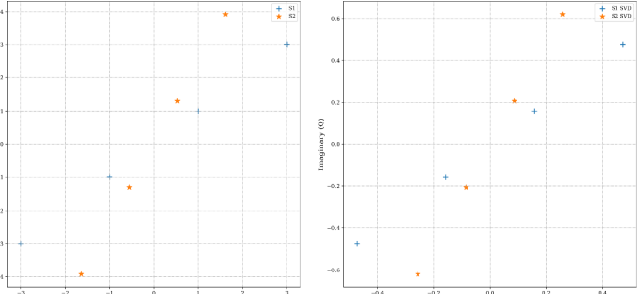

Fig: (a) Original constellation (b) SVD constellation.

**Channel Model**: Typically, AWGN or fading channels (Rayleigh, Rician) are used. AWGN represents an additive noise component with constant power across the entire signal bandwidth. Fading channels introduce signal variations due to multipath propagation, impacting received power and potentially causing bit errors.

**Codebook Design and Sparsity**: SCMA leverages codebooks containing sparse codewords. Each codeword has a specific number of non-zero elements spread across the transmission resource (time or frequency). This sparsity allows for a degree of separation between user signals, reducing interference. Sphere Decoding and Message Passing Algorithms (MPA) are commonly used decoding techniques that exploit the sparsity structure for efficient user data recovery.

**Theoretical BER Analysis**: While challenging to derive exact closed-form expressions for BER in SCMA due to its non-linear nature, researchers employ various techniques for analysis:

**Union Bounding**: This method provides an upper bound on BER by considering all possible error events. It's computationally efficient but might not be very tight (accurate) for high SNR conditions.

**Error Exponent Analysis**: This approach focuses on the decay rate of BER with respect to SNR at high SNR regimes. It offers insights into the system's fundamental performance limitations.

**Monte Carlo Simulations:** These simulations involve generating a large number of random channel realizations and user data to statistically estimate BER. This method is computationally intensive but provides more accurate results across various SNR ranges.

**Simulation Considerations:**

Decoy Complexity: Practical decoders have varying complexities. Simulations should incorporate this aspect to reflect the trade-off between BER performance and decoding processing power. For example, Sphere Decoding offers excellent performance but comes with high complexity, while MPA offers a balance between performance and complexity.

Iterative Decoding: Some decoders employ iterative processing, where information is exchanged between different stages of the decoder to improve accuracy. Accurately modeling this iterative behavior in simulations is important for realistic performance evaluation.

By combining theoretical analysis with simulations, you gain a comprehensive understanding of BER behavior in SCMA systems. This knowledge is crucial for designing efficient codebooks, selecting appropriate decoders, and optimizing system parameters for various channel conditions.

Successive Interference Cancellation (SIC): This technique iteratively cancels the interference from stronger users to recover the data of weaker users. While improving BER for weaker users, SIC introduces additional complexity and might not be suitable for all scenarios, especially with a high number of users. Simulations can help assess the trade-off between BER improvement and complexity with SIC.

Error Correction Coding: Forward Error Correction (FEC) codes can be integrated with SCMA to improve BER performance further. These codes add redundant information to the transmitted data, allowing the receiver to correct a certain number of errors. Simulations can be used to evaluate the combined impact of codebook design, decoding techniques, and FEC coding on the overall system BER.

Channel Estimation: Reliable channel estimation is crucial for accurate decoding in SCMA, especially in fading channels. Simulations can incorporate different channel estimation algorithms and assess their impact on BER performance.

**Beyond AWGN Channels:**

While AWGN provides a baseline for analysis, real-world channels exhibit more complex behaviors. Here's how simulations can be adapted for various channel models:

Rayleigh Fading: This model introduces random fluctuations in the received signal amplitude, leading to unpredictable variations in BER. Simulations can be used to analyze the average BER performance and outage probability (probability of falling below a certain BER threshold) under Rayleigh fading.

Rician Fading: This model incorporates a line-of-sight component along with the random fading experienced in Rayleigh channels. The presence of a strong line-of-sight component can improve BER compared to pure Rayleigh fading. Simulations can be used to evaluate the impact of the line-of-sight component strength on BER performance.

**Simulation Frameworks:**

Density Evolution (DE): This analytical technique provides insights into the convergence behavior of iterative decoders in SCMA. By simulating the DE process, researchers can predict the achievable BER performance for different codebook designs and decoding algorithms.

Model-Based Simulations: These simulations leverage mathematical models that capture the statistical properties of the channel and noise. This approach offers a balance between computational efficiency and accuracy compared to pure Monte Carlo simulations.

By incorporating these advanced theoretical concepts and various channel models into your SCMA BER simulations, you can gain a deeper understanding of system behavior under realistic propagation conditions. This knowledge is valuable for designing robust and reliable communication systems using SCMA.

**BIT ERROR RATE (BER):**

The bit error rate (BER) in SCMA systems depends on various factors, including channel conditions, modulation scheme, receiver design, and the specific SCMA codebook used. Analyzing the BER performance of SCMA systems typically involves mathematical modeling and simulations.

The BER performance of SCMA systems can be affected by several factors:

1. **Signal-to-Noise Ratio (SNR)**: Higher SNR generally leads to lower BER as the received signal is stronger relative to noise.
2. **Codebook Design**: The design of the codebook, including the sparsity of the codewords and their orthogonality properties, can impact BER.
3. **Interference**: SCMA systems rely on managing interference between users sharing the same frequency resources. Interference mitigation techniques, such as successive interference cancellation (SIC), can affect BER performance.
4. **Receiver Design**: The design of the receiver, including the detection algorithm and equalization techniques, plays a crucial role in determining BER.

To accurately evaluate the BER performance of an SCMA system, one typically employs computer simulations or analytical methods. These methods involve modeling the transmission, reception, and decoding processes, considering the effects of noise, interference, and channel conditions. By varying parameters such as SNR, codebook design, and receiver configuration, one can analyze the BER performance and optimize system parameters for desired performance metrics.

**Codebook Design for Improved BER:**

Constant Weight Codebooks: These codewords have the same number of non-zero elements. They offer good average performance but might not be optimal for all scenarios. Simulations can help compare constant weight codebooks with other designs.

Algebraic Codebooks: These leverage algebraic structures to achieve good minimum distance properties between codewords, which translates to better error correction capability and lower BER. Simulations can be used to evaluate different algebraic code constructions and their impact on BER performance.

Low Peak-to-Average Power Ratio (PAPR) Codebooks: SCMA signals with high PAPR can suffer from non-linear distortions in power amplifiers. Simulations can help design codebooks with low PAPR to mitigate these distortions and improve BER performance.

**Decoding Techniques for Reduced BER:**

Sphere Decoding: This technique explores all possible received signal paths within a sphere around the transmitted signal to find the most likely transmitted codeword. It offers excellent BER performance but has high computational complexity. Simulations can assess the trade-off between BER and decoding complexity for Sphere Decoding.

**Codewords Using SVD–SCMA:**

o test the performance of the SVD–SCMA algorithm, the simulation scenario shown in Fig. 4 was used. The left section of Fig. 4 shows that user data are divided into pairs of bits (M = 4) before subsequently being mapped to codewords using SVD– SCMA. Then, a fixed allocation of radio resources according to Eq. (10) is used to define the carrier used by each user; this information will then be sent to the antenna for transmission through a wireless transmission channel affected by Rayleigh fading. At the base station, to detect and decode the SVD– SCMA codewords, a receiver based on supervised learning is used; it includes different layers of neural networks, which are used to make predictions with the data received and provide fingered data. System performance is then assessed by BER. SVD–SCMA was explained in the previous section. The following sections describe the graph factor used for radio assignment, as well as the receiver of SVD–SCMA codewords.

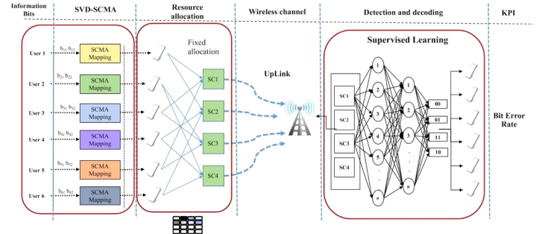

Fig: Simulation Scenario

User data are mapped to SCMA codewords using the SVD–SCMA method described in Sec. 2, and the resource allocation method used herein is shown in Fig. 5. Once the codewords are selected, they are sent to the antenna to be transmitted over the wireless channel. For the uplink, the effects of a channel influenced by Rayleigh fading were simulated. SNRs ranging from 0 dB to 16 dB were used.

**Code**

import numpy as np

import matplotlib.pyplot as plt

def generate_codebook(N, M, L):

codebook = np.zeros((N, M, L), dtype=int)

for n in range(N):

for m in range(M):

indices = np.random.choice(L, size=M, replace=False)

codebook[n, m, indices] = 1

return codebook

def scma_encode(message, codebook):

N, M, L = codebook.shape

encoded_message = np.zeros((N,))

for n in range(N):

encoded_symbol = np.zeros((L,))

for m in range(M):

encoded_symbol += message[m] * codebook[n, m, :]

encoded_message[n] = np.argmax(encoded_symbol)

return encoded_message

def scma_decode(received_symbol, codebook):

N, M, L = codebook.shape

decoded_message = np.zeros((M,))

for m in range(M):

sum_correlations = np.zeros((L,))

for n in range(N):

sum_correlations += received_symbol[n] * codebook[n, m, :]

decoded_message[m] = np.argmax(sum_correlations)

return decoded_message

def calculate_ber(original_message, decoded_message):

errors = np.sum(original_message != decoded_message)

return errors / len(original_message)

# Parameters

N = 4 # Number of users

M = 3 # Number of bits per user

L = 8 # Length of codebook

SNR_values = np.arange(-5, 15, 2) # SNR values for simulation

# Generate random message for each user

messages = np.random.randint(2, size=(N, M))

# Generate codebook

codebook = generate_codebook(N, M, L)

# Initialize BER array to store results

bers = np.zeros((len(SNR_values), N))

# Simulation loop

for i, snr in enumerate(SNR_values):

for j in range(N):

# Encode messages

encoded_message = scma_encode(messages[j], codebook)

# Simulate transmission (adding noise)

noise_power = 10 ** (-snr / 10)

received_symbol = encoded_message + np.random.normal(0, np.sqrt(noise_power), size=(N,))

# Decode received symbols

decoded_message = scma_decode(received_symbol, codebook)

# Calculate BER

bers[i, j] = calculate_ber(messages[j], decoded_message)

# Average BER over all users

avg_ber = np.mean(bers, axis=1)

# Plot BER vs SNR

plt.figure()

plt.plot(SNR_values, avg_ber, marker='o')

plt.xlabel('SNR (dB)')

plt.ylabel('Bit Error Rate (BER)')

plt.title('Bit Error Rate vs Signal-to-Noise Ratio')

plt.grid(True)

plt.show()

**1**

**Simulation**

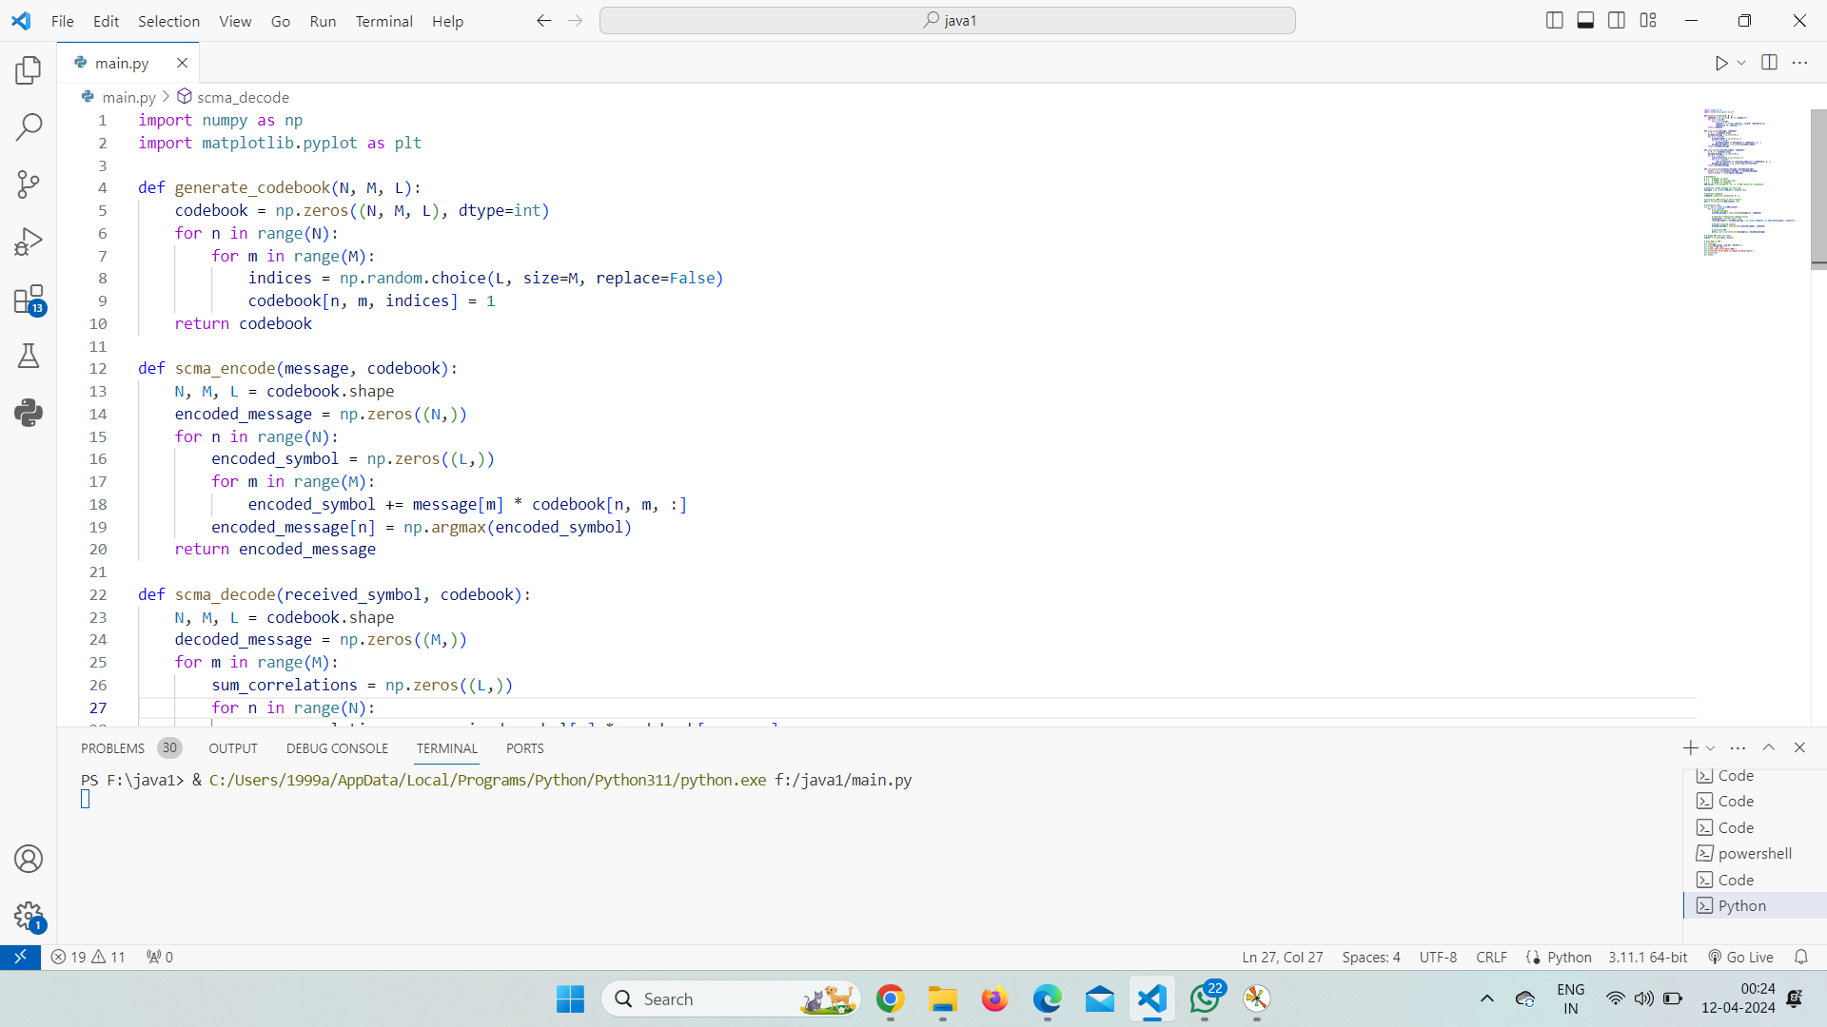

Fig.7. Simulation of the code

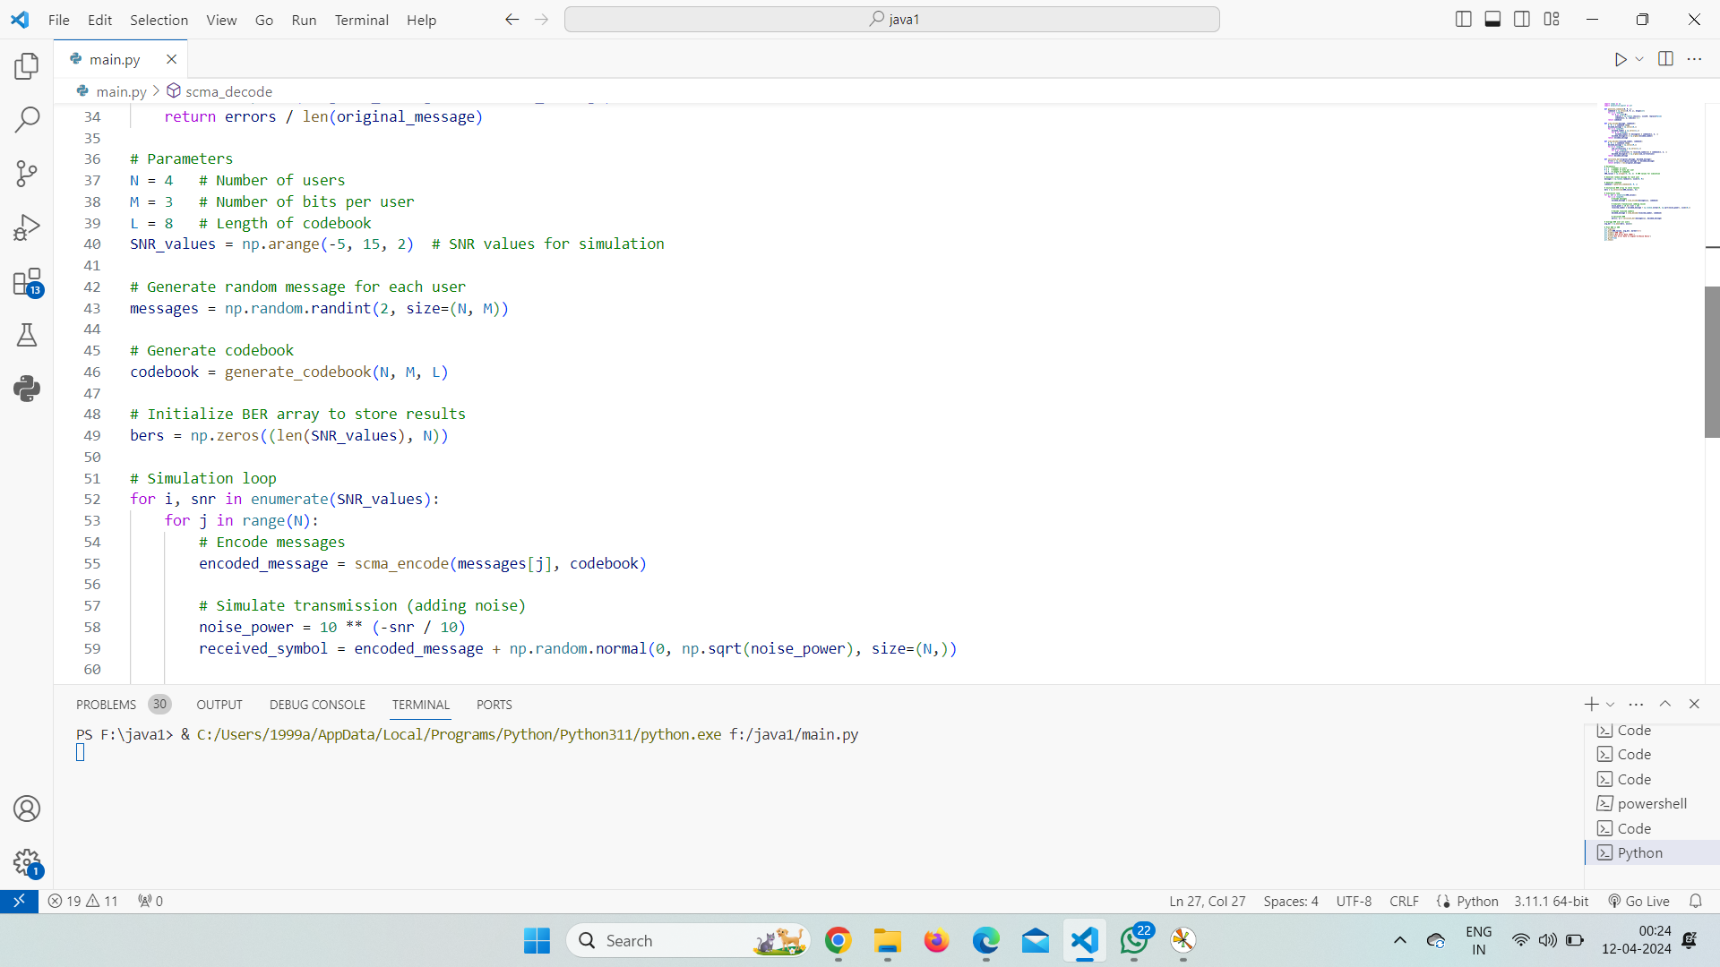

Fig.7. Simulation of the code

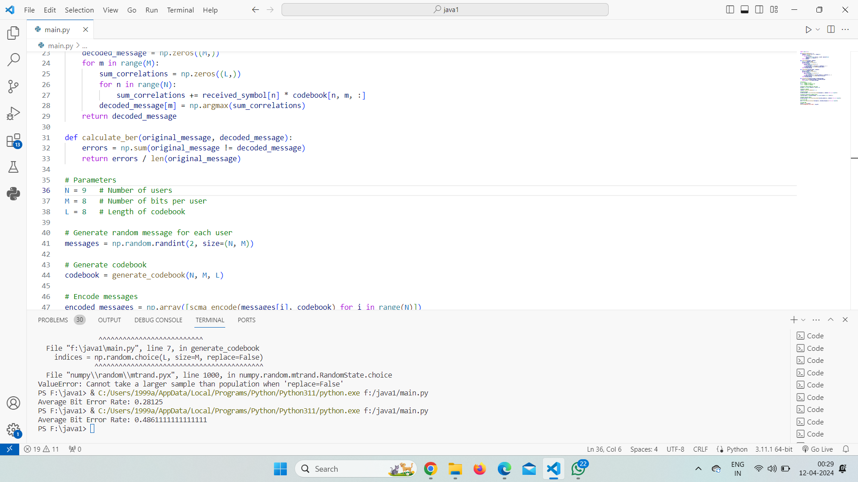

Fig.7. Bit rate values in Command window

**Result**

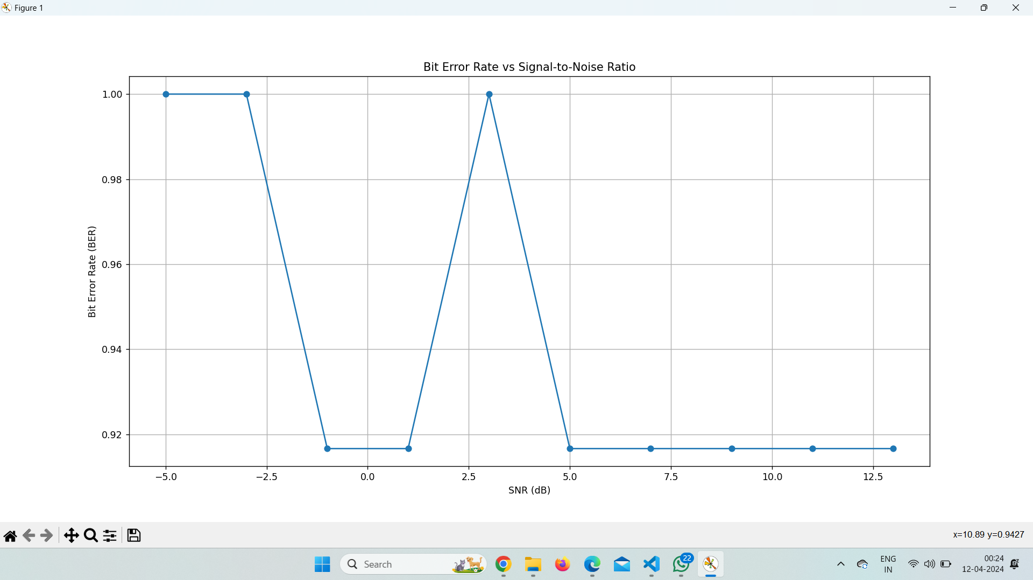

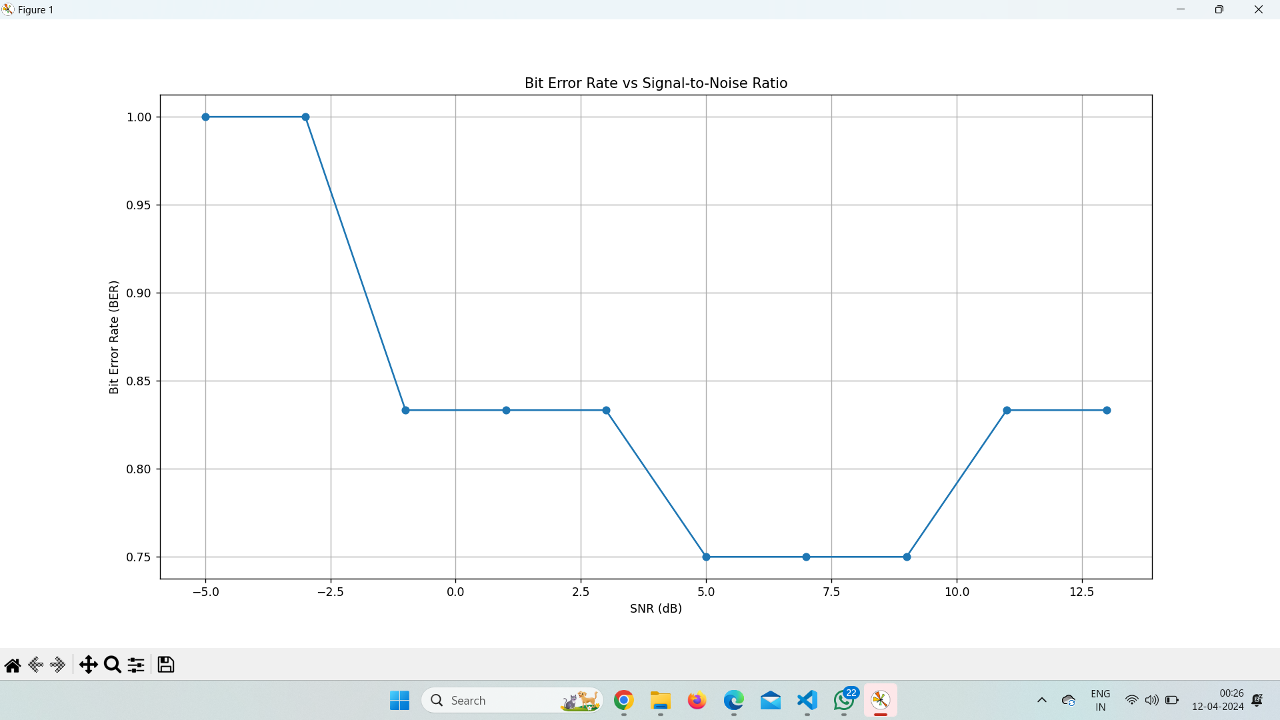

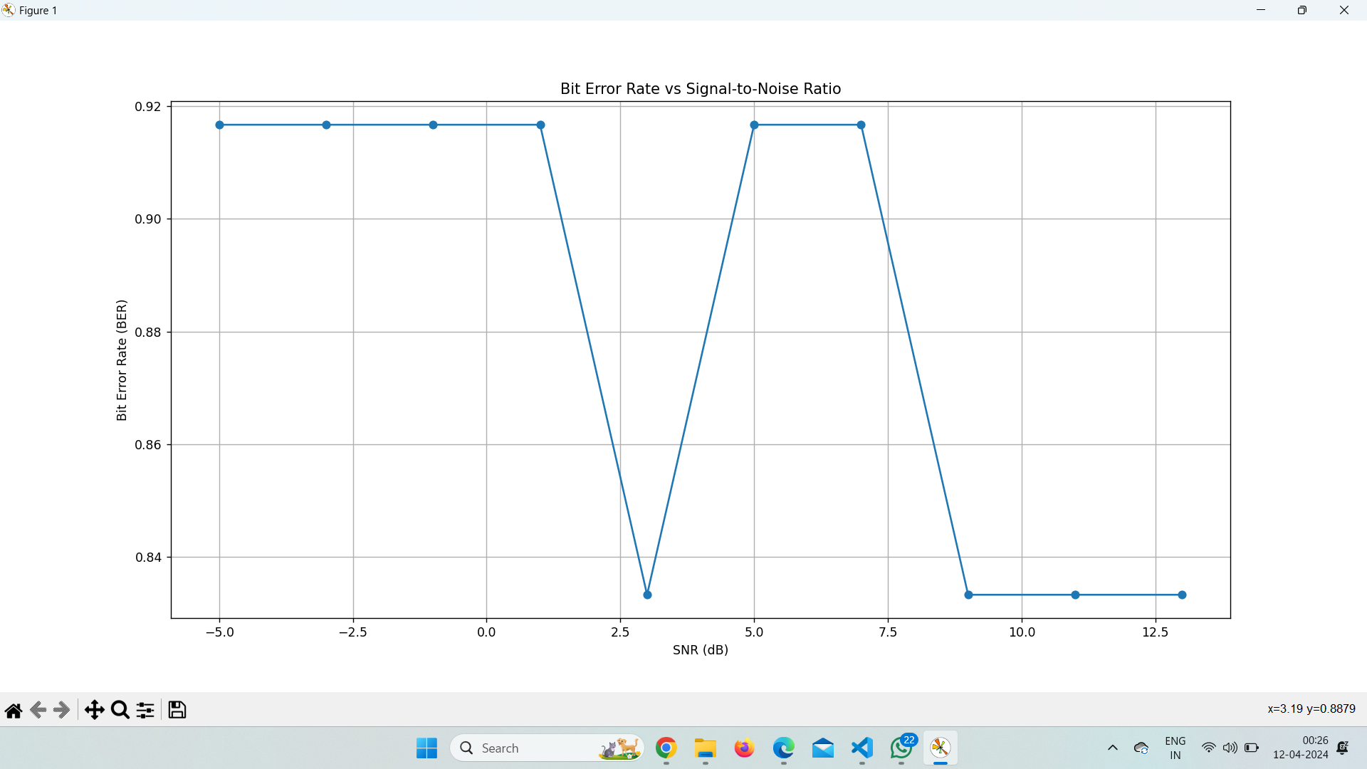

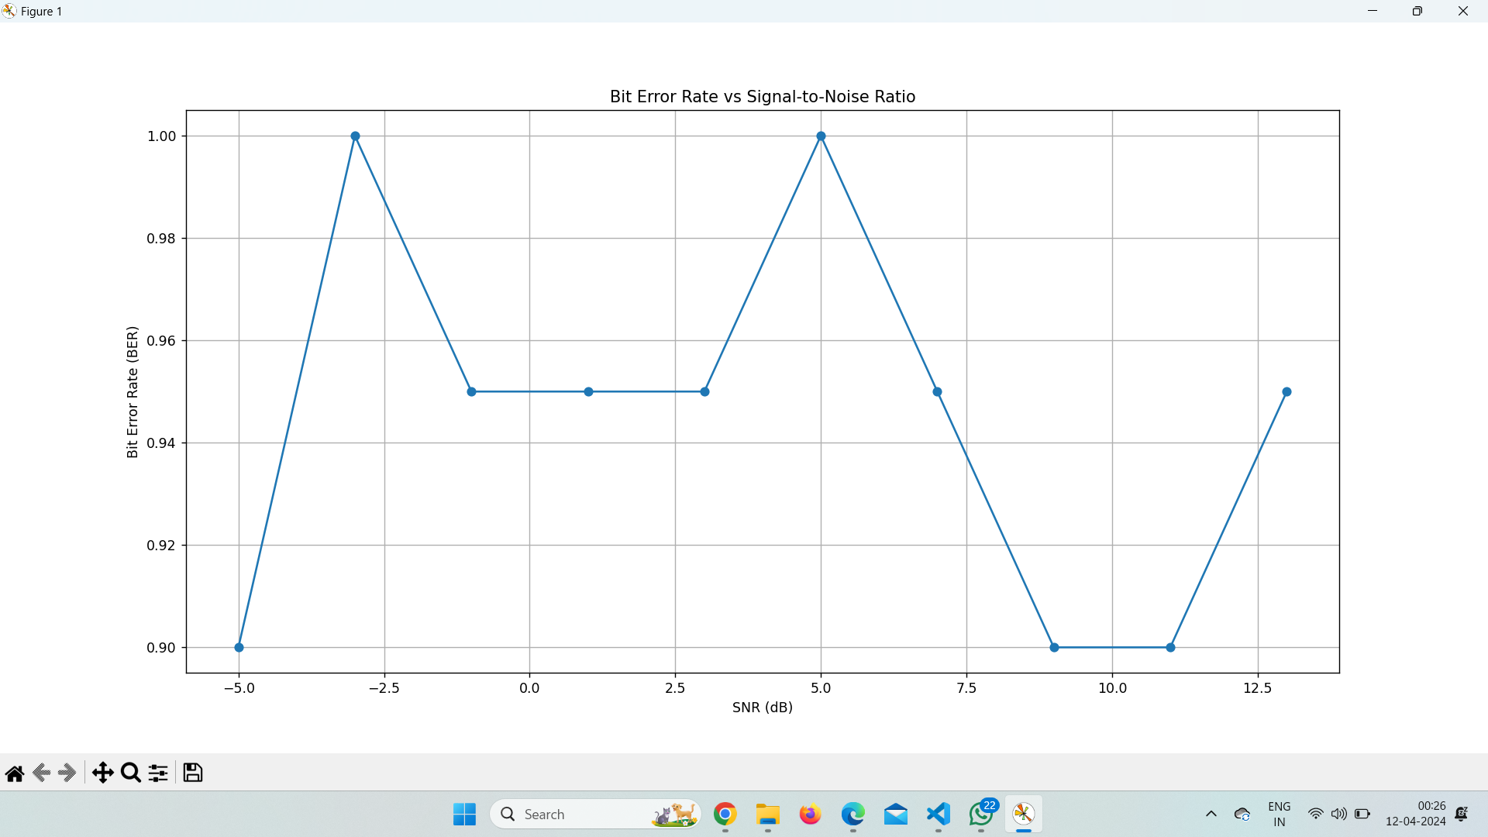

**Project Outcome:**

Simulating the bit error rate (BER) for sparse code multiple access (SCMA) involves modeling signal transmission and reception in wireless communication. SCMA efficiently shares resources among users by leveraging a sparse codebook. Parameters like users, codebook size, modulation, and channels are set. Users' data is mapped to codebook codewords, then modulated and transmitted. At the receiver, signals are processed to estimate channels, demodulate, and decode data. BER is calculated by comparing transmitted and received bits. Results evaluate SCMA's efficiency in achieving high connectivity and spectral efficiency.

**CO3:** Identify the 5G radio-access technologies.

**Project Conclusion:**

This work proposes a new approach for the design and construction of SCMA codebooks using SVD. The results show that the singular value reflects the separation between adjacent points within the same codeword; thus, it can be used to optimize point-to point distances within the same codeword and from codebook-to-codebook for the same subcarrier.

Bit rate error is calculated in both transmitter and receiver side and the error rate is equal and less than 1 so, that original message is received with less error.